**BANKING SYSTEM IN C++**

**Objective:**

The main objective of this banking system which is developed in c++ is to provide a flexible solutions for banking industry. With this system both type of users such as bank customers and working personnel of the particular bank will find easy to use and able to perform all their operations using this system. This system enable its users to open and close the bank account. Customers will able to withdraw and deposit amount to their particular account. It will also able to generate transactions on money for particular customer account.

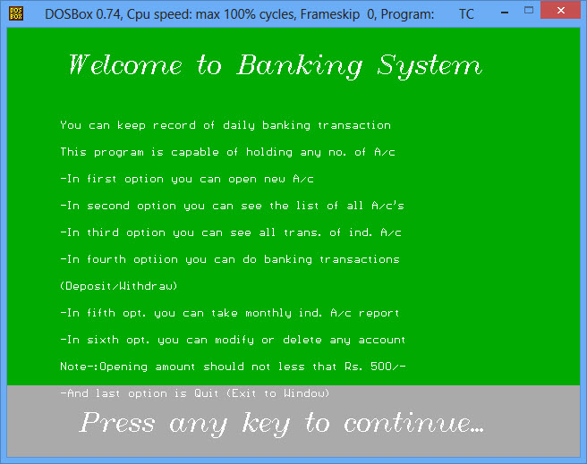

Working personnel of the particular bank will make to make all the operations which are required within the banking premises. The operations which can be performed by the bank personnel are: Adding new customer account, edit existing customer account, list all customer details including their account number, able to generate daily and monthly business transactions report etc. Its user friendly graphical mode will made its users to work with this new system in more interactive way.

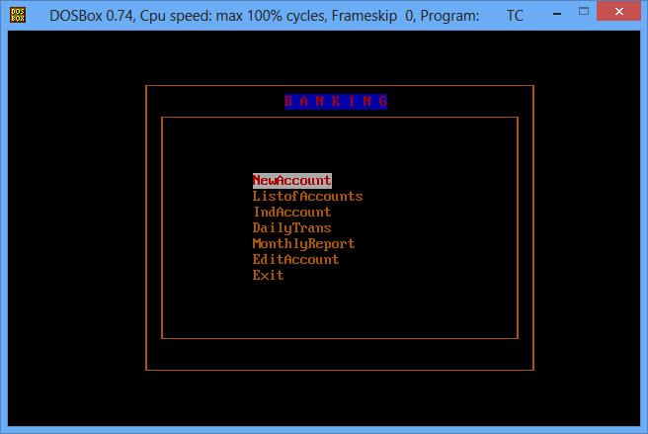

To perform operations such as adding customers account, a particular form will be appear under all fields should be entered correctly. If there will be any error while entering the data, system will not accept those values and its data will not be saved in the file.

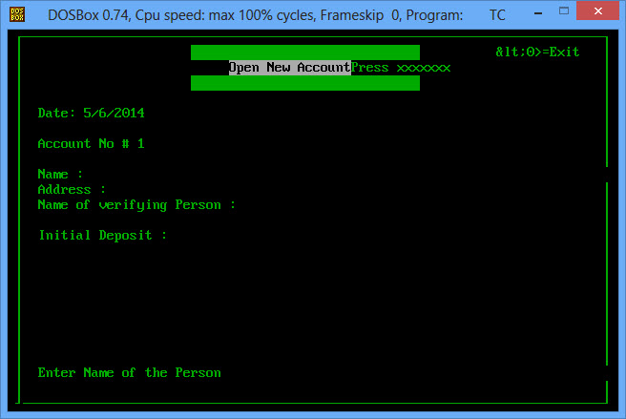

**Existing System:**

Existing system do not provide a user friendly environment to work the system. Existing system is not developed in such a way which can be easily handled by the end user. Under this system, users are not able to generate transactions statement and this system was not developed in such a way that it can be used by their customers also. This system does not uses the concept of authentication and validation before using the system and thus security measures was a major issue under the existing system. Under existing system, the concepts of graphics was not implemented and thus all processing was done by entering certain command which cannot be used by the end users and proper training given to the working personnel of the particular bank.

**Proposed System:**

This new system has the potential to perform all the activities which are required to make a successful bank. This interactive system will able to provide customers all the information just by single click. Even working personnel will also able to make their query and able generate results as per their requirement. This new system has unique authentication and validation which will identify the type of users and as per that, it will provide particular working screen for particular users by which confidentiality can be maintained and do not get prone to any errors.

